6.9 Healthy Lunch Box Policy (updated sept 2024)
Incorporating any other food brought from home
The aim of the policy is to ensure that all food and drinks brought from home, consumed at pre school provides pupils with healthy and nutritious food.

Procedures
This policy is intended to:
- Make a positive contribution to children’s health
- Support the preschool’s Food and Drinks Policy
- Encourage a happier and calmer pre school population
- Contribute to the self-evaluation for review by OFSTED
- Promote consistency between food brought from home and food provided by the pre school

The policy applies to:
- All food brought from home to be consumed in preschool at lunch time or at other times during the preschool day.
- All staff eating food brought from home within school or on a school trip in the presence of pupils.

Intake Preschool’s responsibility
Intake preschool will ensure that eating food from home is a sociable experience where staff will provide integrated and wrap around care. Our policy aims to enhance this by:

- Providing a dining environment that is appropriate, hygienic and attractive with a seat and a place to eat
- Ensuring good behaviour and consideration for others is maintained
- Providing fresh drinking water at all times
- Staff supervising children eating food from home are aware of our preschool policy and hygiene procedures

Intake Pre school is not responsible for providing:
- Fridge space, so requests that food from home is in insulated bags with freezer blocks or frozen drinks cartons to keep food cool, appetising and safe where possible.

Special diets and allergies
- Intake pre school recognises that some children may require special diets for medical, ethical or religious reasons that do not allow for standards to be met exactly. For example a diabetic child may need to bring an emergency sweet snack to pre school. In these cases parents and carers are responsible for ensuring the food from home is specific for the child’s needs.
- Intake pre school does not allow the swapping of food items between children as there is potential for an adverse reaction (e.g. Nut allergy)

We would like all Lunch Boxes to include:

- At least one portion of fruit (e.g. small apple, orange, grapes, dried fruit, cherry tomatoes) should be included each day
- At least one portion of vegetables (e.g. carrot sticks, cucumber, celery) should be included each day
- Meat, fish or other source of non-dairy protein (e.g. chicken, turkey, ham, beef, pork, tuna, lentils, kidney beans, chickpeas, hummus, peanut butter and falafel) should be included each day
- Oily fish such as salmon at least once every three weeks
- A starchy food such as any type of bread, pasta, rice, couscous, noodles, potatoes or other type of cereals every day (e.g. pitta bread, tortilla wraps, rice cakes, oat cakes) should be included each day
- Dairy food such as milk, cheese, yoghurt, fromage frais or custard should be included each day
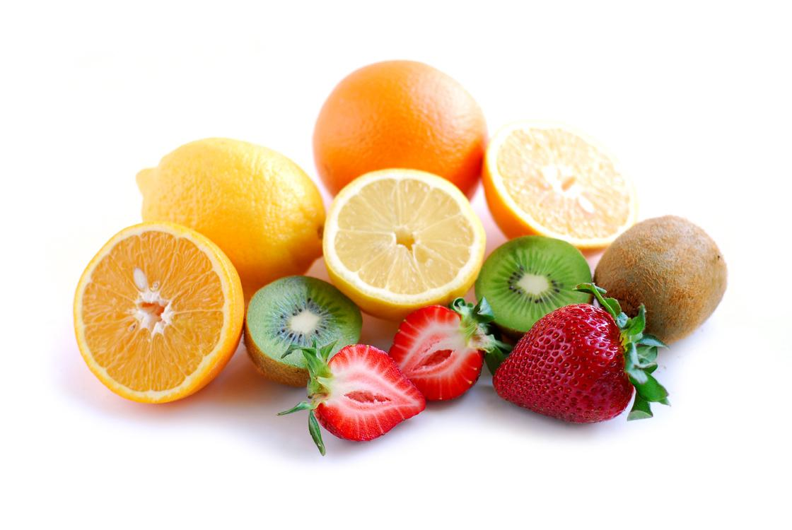
- Drinks should be water, fruit juice, semi-skimmed or skimmed milk, yoghurt or milk drinks and smoothies
Aim to avoid:

- Snacks such as crisps (alternatives include savoury crackers, breadsticks, nuts and seeds)

- Confectionery such as chocolate bars, chocolate coated biscuits and sweets (alternatives include small cakes, shortbreads and flapjack or plain biscuits)

- Fizzy drinks, drinks with added sugar or sweeteners

- Flasks, drinks in glass bottles or ring pull cans

- The remains of the previous days take-away

Lunch Boxes should not regularly include items that are high in fat or salt. For example:

Cooked sausages, sausage rolls, chipolatas, corned meat, individual meat pies

Items that will not be allowed:

- Energy drinks / fizzy drinks

- Sweets that are a potential hazard to others such as tic-tacs, hard boiled sweets.

In implementing the Policy our preschool should aim to:

- Inform parents and carers and children of the policy via letter, the preschool newsletter and the preschool website, including ideas for a healthy lunch box.
- Use all opportunities to promote this policy as part of the whole preschool approach to healthy eating
- Ensure that all staff are informed of the policy and support its implementation
- Train staff to support the implementation of the policy
- Contact the parents and carers if a child regularly brings a lunch box which does not conform to the policy to discuss and find a way forward
- Discuss with parents and carers food from home that is regularly not eaten by their child.

Further guidance
- Sheffield HENRY Project

This policy was adopted by | Intake Pre-School | (name of provider)
On | 30/09/22 | (date)
Date to be reviewed |  | (date)
Signed on behalf of the provider | D.White
Name of signatory | Daniel White
Role of signatory (e.g. chair, director or owner) | Chair

